# CS 340 README

## About the Project/Project Title

## This Project is called Rescue Dogs. The goal of this project is to take data from a MongoDB database and perform different searches, grouping, filtering, and more on it from a Dash Framework site.

## Motivation

## The motivation for this project was to help make a simpler way of interacting with MongoDB as well as help visualize the data we have in an easy-to-understand way. The way that we can accomplish this is by implementing the Dash Framework in creating a web GUI that allows someone to interact with our data, filter it based on predetermined filters, and filter it through the chart. This will let someone easily interact with a lot of the data without having to create unique MongoDB statements and allow us to visualize the outputs in easy-to-understand charts.

## Getting Started

To get started with this project you would need to create or import the database. For this, we are using the Austin Animal Clinic database. Below is a screenshot of the import process for it.

Afterward, we will need to create the indexes for the database. Next, we can move to the user account creation for securing our database. For my users, I provided them with read-write access to our AAC database.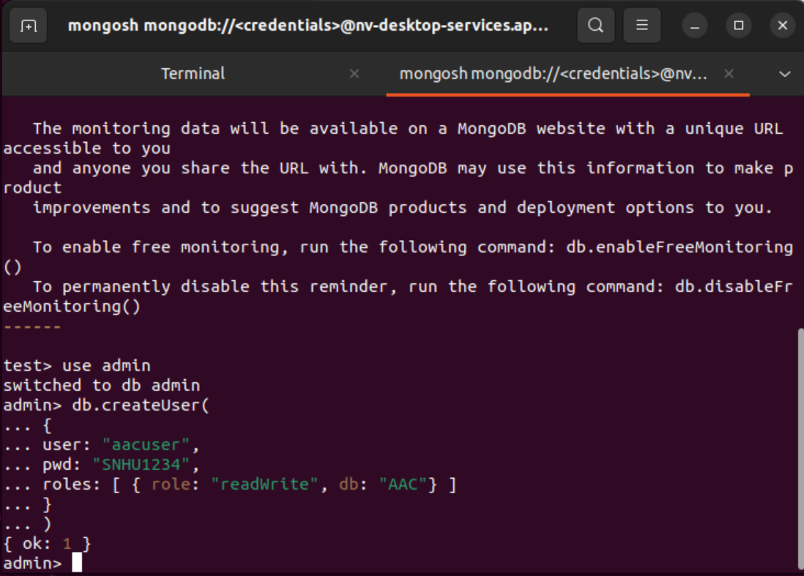

I also tested the user account to ensure that it had worked inside Mongoshell before creating any of the Python scripts and tests. This is an example of the test that I completed with it. This ensured that both the admin and the new user account worked correctly.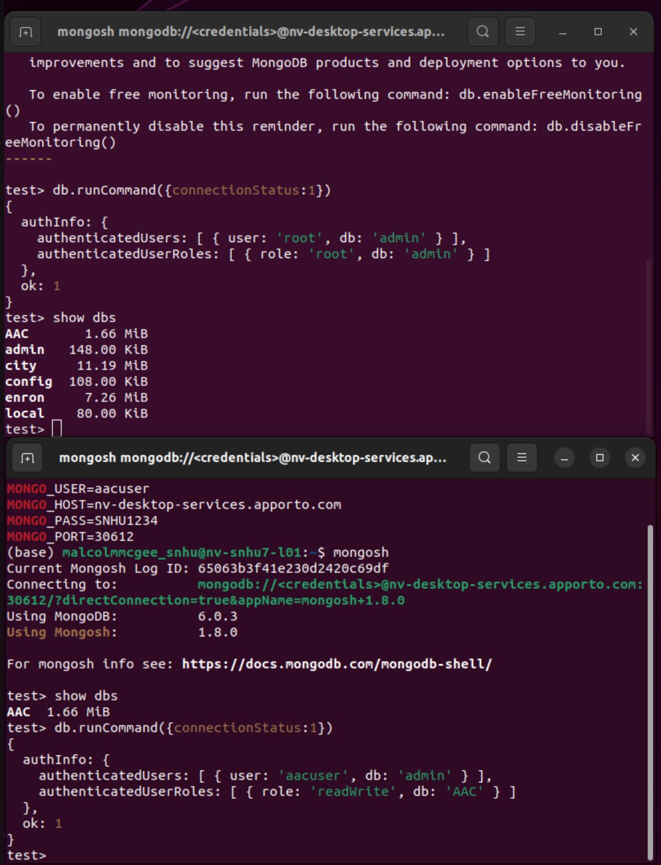

## From there we will need to set up user accounts with proper access for reading and writing into the database. It would be best practice to verify that those user accounts are created correctly, by testing queries directly into the database. The next step would be to work on the .py file. We will need the database running and having it linked. You can change the values in the attached file to better represent where your MongoDB instance is, the account credentials, and any other changes. Lastly, you can make edits to the .ipynb file like the username or password to ensure it works for your database. I had some issues with importing the .py file, but after ensuring it was in the same directory as the Jupyter Notebook I was able to confirm that everything was working properly.

## Installation

## The tools needed will be the latest MongoDB stable release, python text editor, and Jupyter Notebook. For this project, python is a necessity. I was able to create the code in a text editor. The reasoning behind Python was due to the well-documented integration options it has with MongoDB. When looking at MongoDB it is advised to start using the latest MongoDB stable version so I will be recommending that. This project was done in version 6.0.3 but should be compatible with later versions. Lastly, we are using Jupyter Notebook because it allows us to easily test our file and see an output. We are also able to pass parameters in Jupyter Notebook as code so we can ensure that the database is authenticated when our Dashboard script runs.

## Usage

### For usage, the client can click one of the boxes and it shows the dogs that are in our database that correspond to those boxes. For this dashboard, we have boxes for Water Rescue, Mountain or Wilderness Rescue, Disaster or Individual Tracking, and a Reset option. For those options, they correspond to traits that were wanted for those types of scenarios, and by clicking the box it easily filters the data based on those requirements. You can also reset the chart or interact with the table to do unique filtering for a new search. This filtering will also update the visual chart at the bottom to help visualize the data.

### Code Example

This code shows the animal shelter code and some of the Dashboard code. I wanted to go over this part to help show how helpful the dash framework has been in creating the site. We can see in the code that the dash framework has a lot of options for graphs and tables. The code shows how we can utilize the dash framework to create the filtering options for the table. With the dash framework, we can make filtering options, reset options, and implement things like maps, tables, graphs, and so much more. Without utilizing Dash Framework this project would be significantly more difficult.

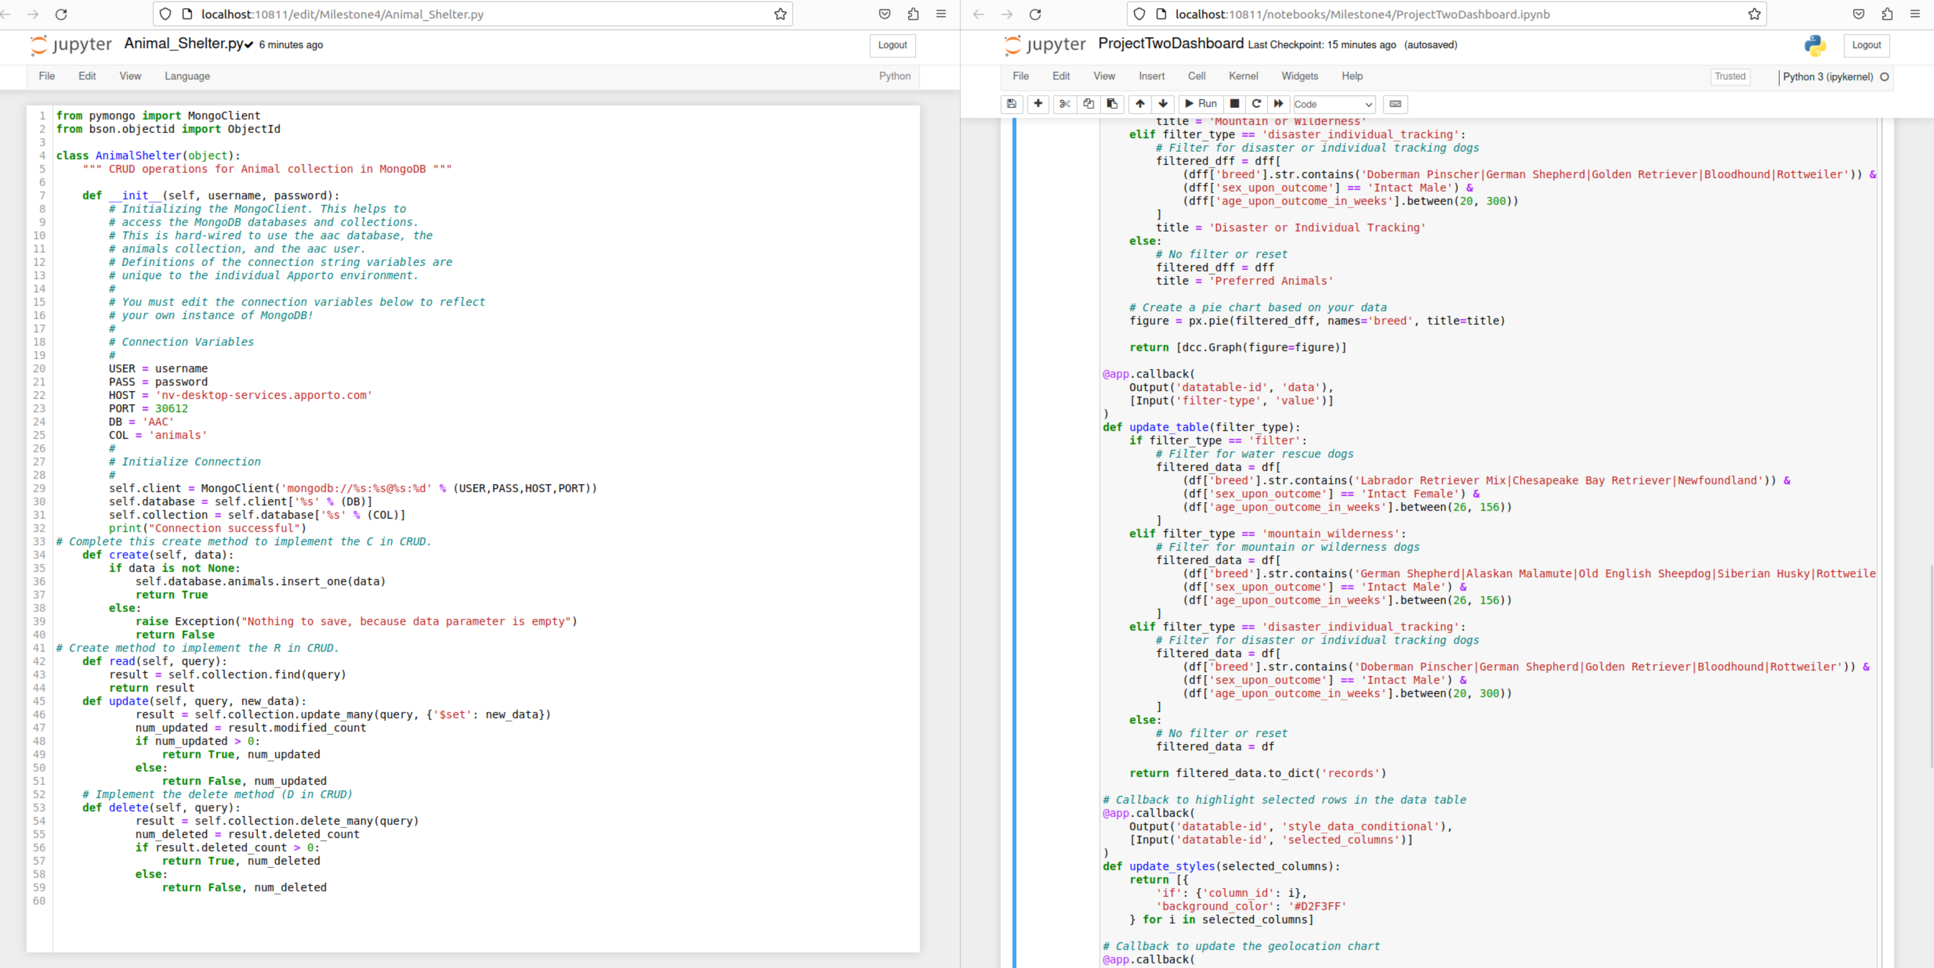

### Tests

While creating the website we hard-coded filters that will run when the appropriate button is selected. These filters go off things like the dog breed, age, and sex. Based on those filters the Table will update with dogs that match that type of filter as well as update the pie chart below based on that data. A great example of this type of filter being run is when we are looking at dogs that are great for Mountain or Wilderness Rescue. We can see that once selected the table updates with relevant searches that fit the requirements we outlined in the code. 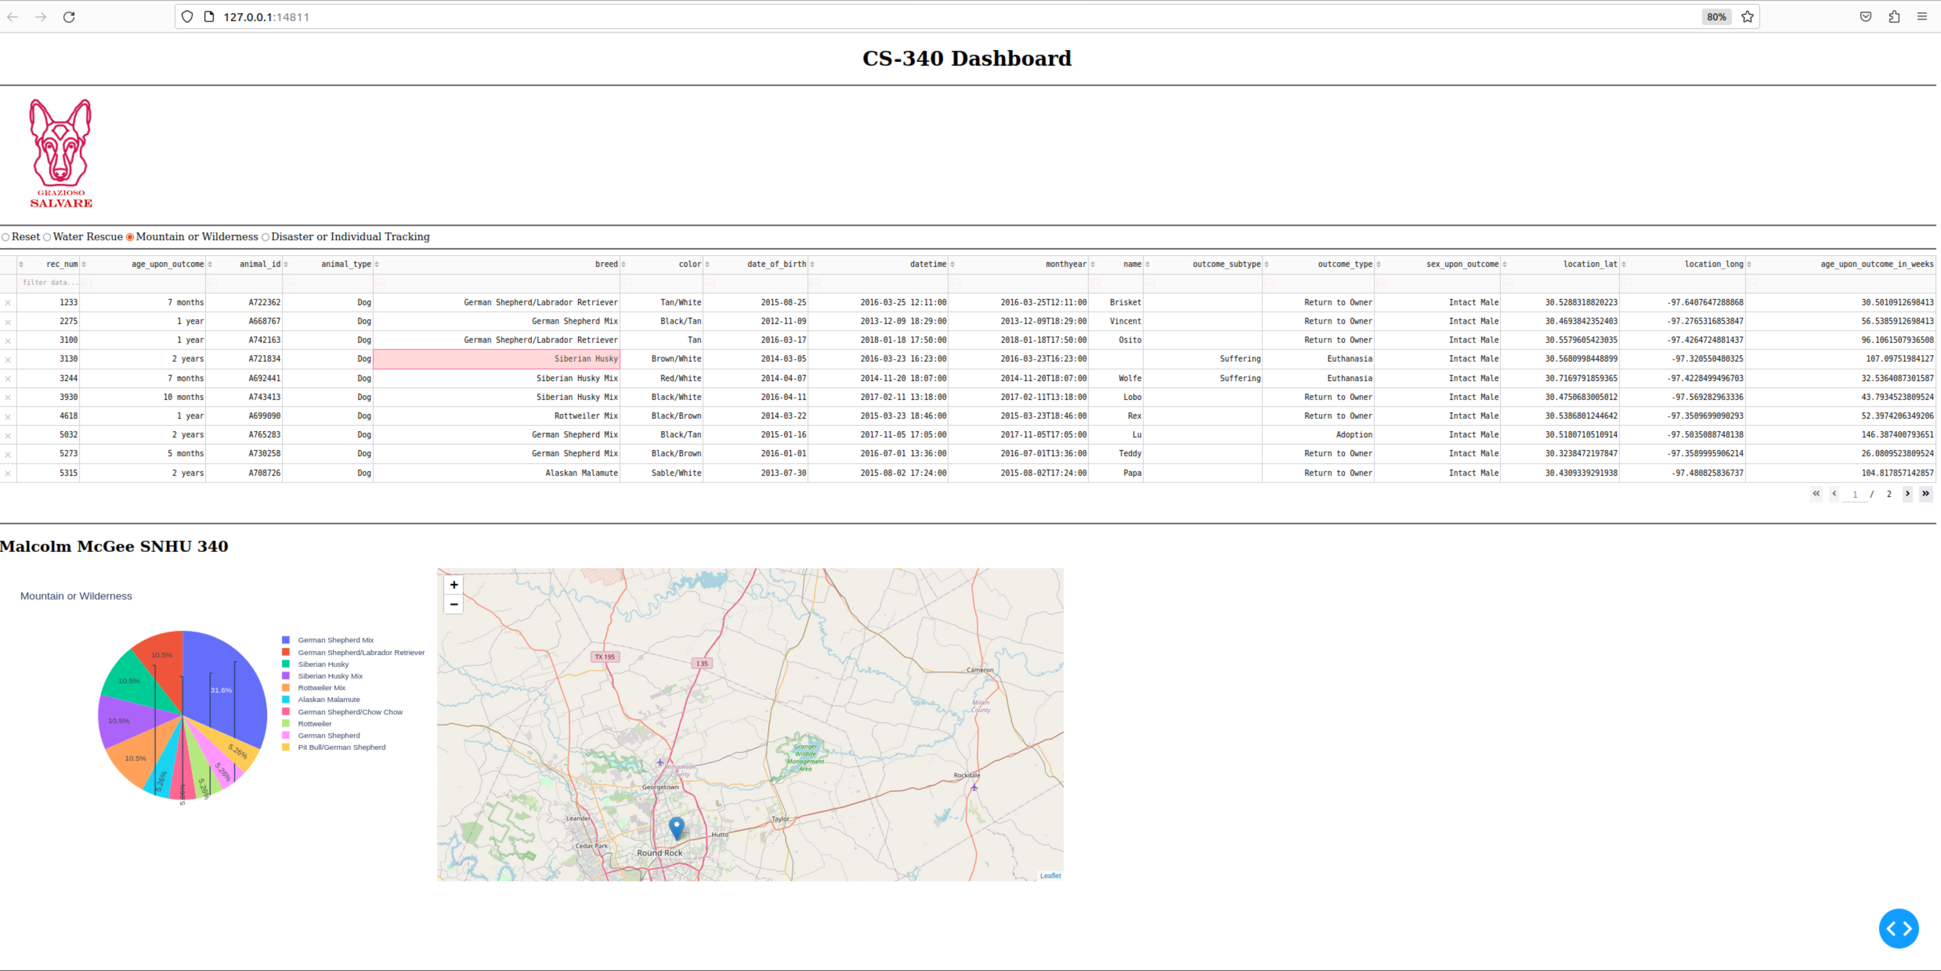

*The detailed details of what each filter does are included below. We can also change this or add new filters based on new rescue categories or wish to expand the dogs that are included in a certain category. This could be a great help when trying to expand the dogs in the water rescue category since it is currently only showing some Labradors that meet the requirements. 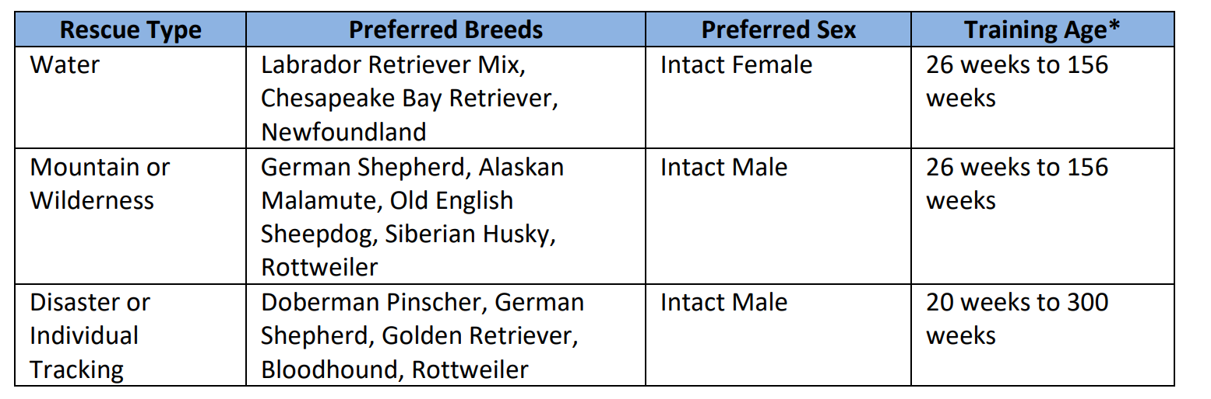*

### Screenshots

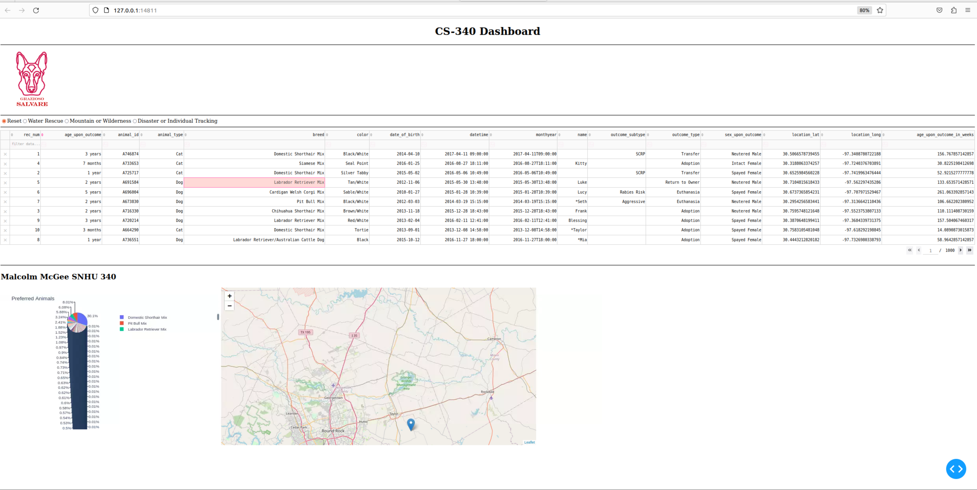

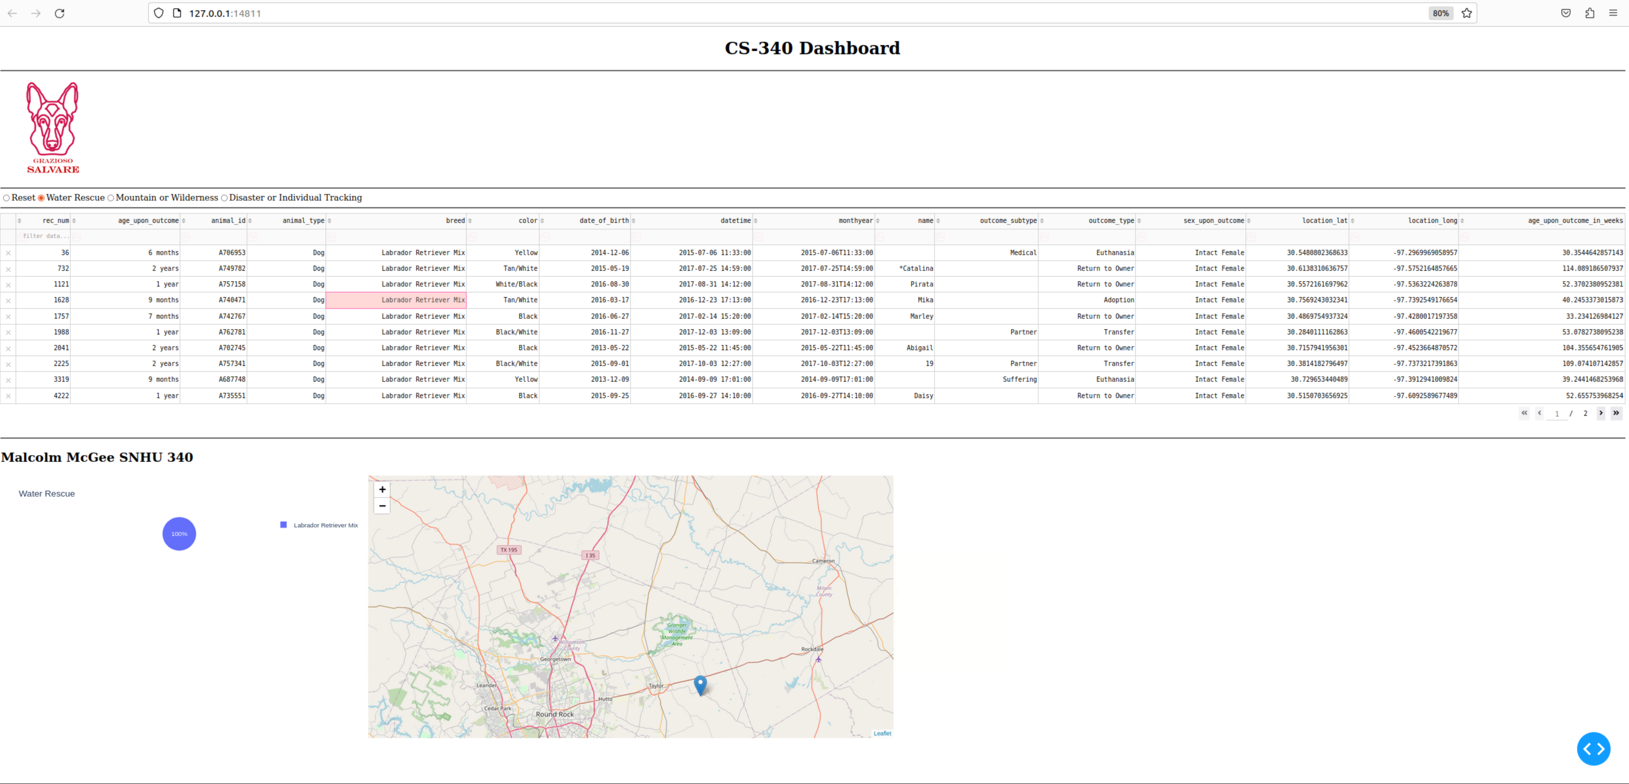

**

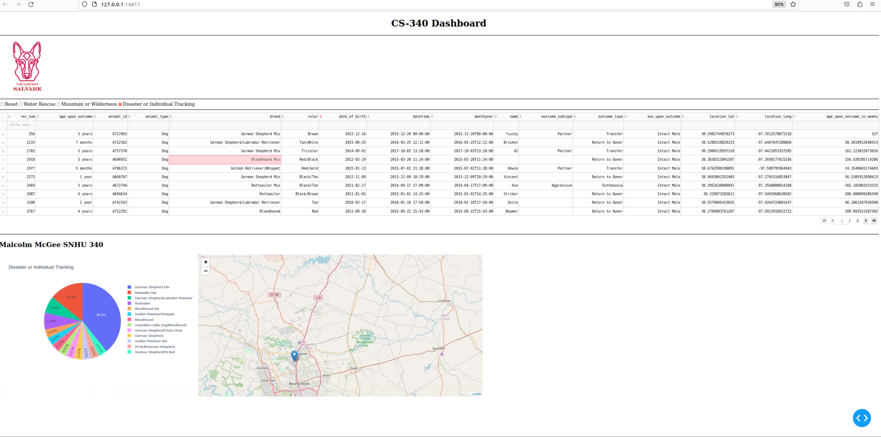

## Contact

Your name: Malcolm McGee